LAB TASK-8
Name: Naqeebullah
Roll No: (25p-0660)
Section: BCS-1B
Subject: PF-LAB

Question#1
{
int n;
printf("Enter Number of Students\n");
scanf("%d",&n);

int marks;
char students[n];
int i;

FILE*f1;
f1 = fopen("D:\\1st semester 25\\PF LAB\\Lab Task 8\\Q1.txt", "w");
fprintf(f1,"Marks Of Students\n");

for(i=1; i<=n; i++)
{
printf("Enter Name And Marks of Student(%d)\n",i);
scanf("%s %d",&students, &marks);

fprintf(f1, " %s %d\n", students, marks);
}
fclose(f1);
return 0;
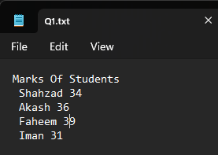
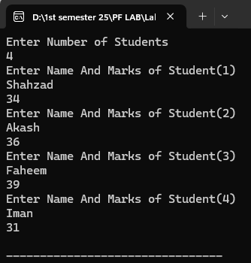
}

Question#2
#include<stdio.h>
int main()
{
int n;
printf("Enter Number of Students\n");
scanf("%d",&n);

int marks;
char students[n];
int i;

FILE*f2;
f2 = fopen("D:\\1st semester 25\\PF LAB\\Lab Task 8\\Q2.txt", "a");
fprintf(f2,"Marks Of Students\n");

for(i=1; i<=n; i++)
{
printf("Enter Name And Marks of Student(%d)\n",i);
scanf("%s %d",&students, &marks);

fprintf(f2, " %s %d\n", students, marks);
}
fclose(f2);
return 0;
}
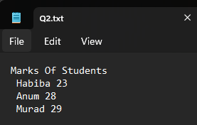
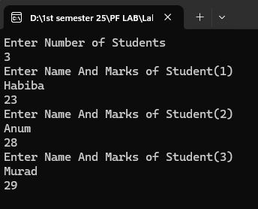

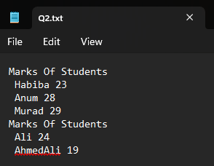
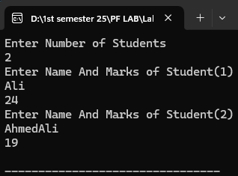

Question#3
#include<stdio.h>
int main()
{

int n,i;
printf("Enter the Number of Members\n");
scanf("%d",&n);

char members[n][50];

FILE*m;
m = fopen("D:\\1st semester 25\\PF LAB\\Lab Task 8\\Q3.txt","w");

for(i=1; i<=n; i++)
{
printf("Enter Name of Member(%d)\n",i);
scanf("%s",members[i]);

fprintf(m, " %s\n",members[i]);
}

fclose(m);

FILE*m1;
m1 = fopen("D:\\1st semester 25\\PF LAB\\Lab Task 8\\Q3.txt","r");

for(i=1; i<=n; i++)
{
fscanf(m1,"%s",members[i]);
}
fclose(m1);

printf("Members Are:\n");

for(i=1; i<=n; i++)
{
printf("%s\n", members[i]);
}
return 0;
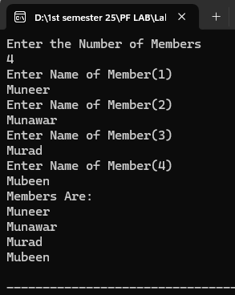
}
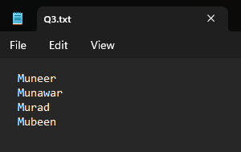

Question#4
#include<stdio.h>
int main()
{
int text;

FILE *fpr1, *fpr2, *fpr3;

fpr1 = fopen("File_One.txt","w");
fprintf(fpr1, "My Name is Naqeebullah\n");
fclose(fpr1);

fpr2 = fopen("File_Two.txt","w");
fprintf(fpr2, "My Roll No is 25p-0660\n");
fclose(fpr2);

fpr3 = fopen("File_Three.txt","w");

fpr1 = fopen("File_One.txt","r");
fpr2 = fopen("File_Two.txt","r");

while ((text = fgetc(fpr1)) != EOF)
fputc(text, fpr3);

while ((text = fgetc(fpr2)) != EOF)
fputc(text, fpr3);


fclose(fpr1);
fclose(fpr2);
fclose(fpr3);
return 0;
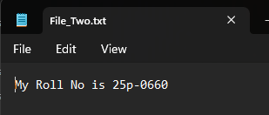
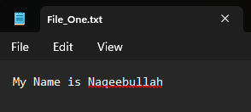
}

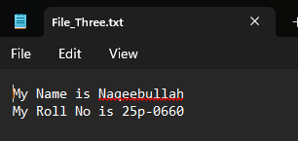

Question#5
#include<stdio.h>
int main()
{
int count=0;
char ltr;
int text;

printf("Enter The letter Do You Want To Count\n");
scanf("%c", &ltr);

FILE *letter;

letter = fopen("D:\\1st semester 25\\PF LAB\\Lab Task 8\\Paragraph.txt", "r");
while((text = getc(letter)) != EOF)
{
if(text == ltr )
{
count++;
}
}

fclose(letter);

printf("The Number of %c in the File is: %d", ltr, count);
return 0;

}

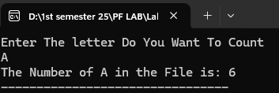
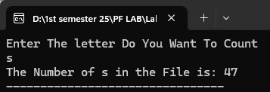

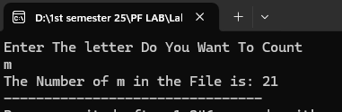

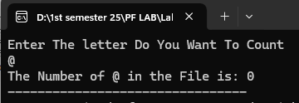

Question#6
#include <stdio.h>
#include <string.h>

int main() {
char str[100], encrypted[100], decrypted[100];
int i;
FILE *fp;

printf("Enter String: ");
fgets(str, sizeof(str), stdin);

if (str[strlen(str)-1] == '\n') str[strlen(str)-1] = '\0';

printf("Normal Text: %s\n", str);

for (i = 0; str[i] != '\0'; i++) {
encrypted[i] = str[i] + (i + 1);
}
encrypted[i] = '\0';

fp = fopen("Encrypted.txt", "w");
if (fp == NULL) {
printf("Error opening file!\n");
return 1;
}
fputs(encrypted, fp);
fclose(fp);
printf("Encrypted Text inserted in file: %s\n", encrypted);

fp = fopen("Encrypted.txt", "r");
if (fp == NULL) {
printf("Error opening file!\n");
return 1;
}

i = 0;
while ((decrypted[i] = fgetc(fp)) != EOF)
{
decrypted[i] = decrypted[i] - (i + 1);
i++;
}
decrypted[i] = '\0';
fclose(fp);

printf("Decrypted Text Read then decoded from file: %s\n", decrypted);

return 0;
}
